

Student Name……………………………………

FURTHER MATHEMATICS

TRIAL EXAMINATION 1

2008

Reading Time: 15 minutes
Writing time: 1 hour 30 minutes

Instructions to students
This exam consists of Section A and Section B.
Section A contains 13 multiple-choice questions from the core, 'Data Analysis'.
Section A is compulsory and is worth 13 marks.
Section B consists of 6 modules each containing 9 multiple-choice questions. You should choose 3 of these modules and answer every question in each of your chosen modules.
Each of the modules is worth 9 marks.
Section B begins on page 9 of this exam.
There is a total of 40 marks available for this exam.
Unless otherwise stated the diagrams in this exam are not drawn to scale.
Students may bring one bound reference into the exam.
An approved graphics or CAS calculator may be used in the exam.
An answer sheet appears on page 40 of this exam.
Formula sheets can be found on pages 38 and 39 of this exam.

This paper has been prepared independently of the Victorian Curriculum and Assessment Authority to provide additional exam preparation for students. Although references have been reproduced with permission of the Victorian Curriculum and Assessment Authority, the publication is in no way connected with or endorsed by the Victorian Curriculum and Assessment Authority.

© THE HEFFERNAN GROUP 2008
This Trial Exam is licensed on a non transferable basis to the purchasing school. It may be copied by the school which has purchased it. This license does not permit distribution or copying of this Trial Exam by any other party.

SECTION A

CORE – Data Analysis

This section is compulsory.

The following information relates to questions 1 and 2.

The weight in kg of 42 Year 3 students is shown on the histogram below.

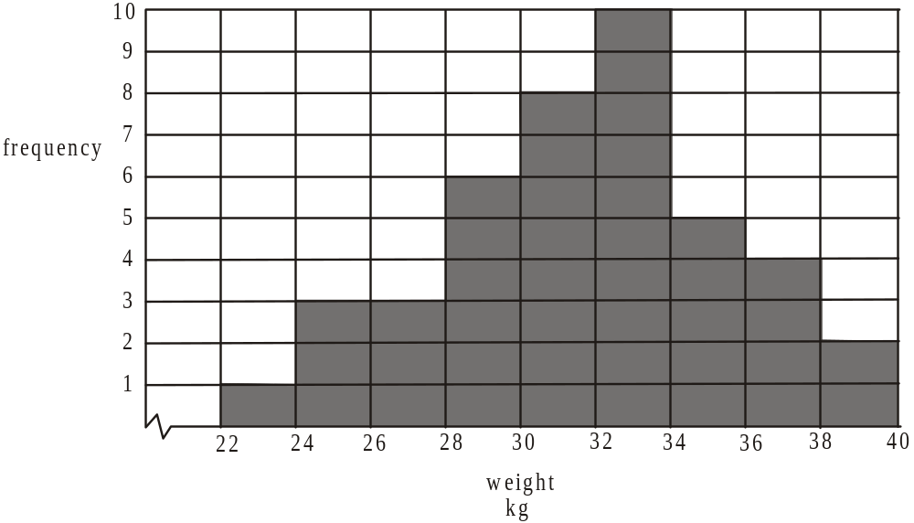

Question 1

The number of students who weigh more than 32kg is

- 11
- 20
- 21
- 23
- 29

Question 2

The percentage of students who weigh between 26 and 30kg is closest to

- 7%
- 10%
- 14%
- 21%
- 43%

Question 3

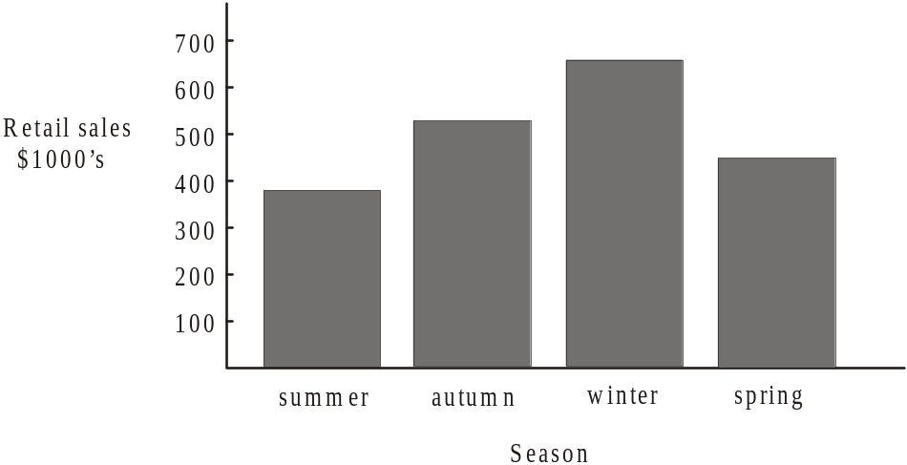

The retail sales of an outdoor adventure shop over a year are shown on the bar chart above.

The two variables displayed can be described as

both categorical
- both numerical
- one numerical but the other not categorical
- neither categorical nor numerical
- one categorical and one numerical

Question 4

The length of steel rods produced by a machine are approximately normally distributed with a mean of 20.5cm and a standard deviation of 0.7cm. The percentage of steel rods that are less than 21.9cm long is

- 95%
- 95.13%
- 97%
- 97.5%
- 99.7%

Question 5

Results in a Year 11 English exam were normally distributed with a mean of 65 and a standard deviation of 11.
John’s result was 71.
His standardized result or z-score is closest to

– 0.92
- – 0.55
- 0.01
- 0.55
- 0.92

The following information relates to Questions 6 and 7.

The distribution of weights (in kg) of female members of two senior citizen clubs X and Y is shown on the back-to-back ordered stemplots below.

Club X Club Y
 |  |  |  |  | 8 | 7 | 5 | 8
 |  |  | 4 | 2 | 2 | 1 | 6 | 2
 | 9 | 9 | 7 | 6 | 6 | 5 | 6 | 6 | 7
4 | 4 | 3 | 2 | 1 | 1 | 0 | 7 | 0 | 3 | 4
 |  | 9 | 7 | 7 | 7 | 5 | 7 | 5 | 5 | 6 | 9
 |  |  |  | 3 | 3 | 0 | 8 | 2 | 2 | 3 | 4 | 4
 |  |  |  |  |  | 7 | 8 | 5 | 7 | 8 | 8
 |  |  |  |  |  |  | 9 | 2 | 3 | 3
 |  |  |  |  |  |  | 9 | 7 | 9
 |  |  |  |  |  |  | 10 | 5

Question 6

The median weight in kg of Club X members is

- 64
- 70.5
- 71
- 71.5
- 82.5

Question 7

By observing the back-to-back ordered stemplot, it can be concluded that the weights of the female senior citizens at Club X are generally

- less than the weights of the members at Club Y and less variable.
- less than the weights of the members at Club Y and more variable.
- greater than the weights of the members at Club Y and less variable.
- greater than the weights of the members at Club Y and more variable.
- similar to the weights of the members at Club Y.

Question 8

The length (in cm) and weight (in grams) of a sample of mice is recorded and displayed on a scatterplot. The equation of the least squares regression line for the data is given by

This means that on average there is

- an 83.7g increase in weight for every 1cm increase in length.
- a 53.2g increase in weight for every 1cm increase in length.
- an 83.7g increase in weight for every 53.2cm increase in length.
- a 53.2g increase in weight for every 83.7cm increase in length.
- a 136.9g increase in weight for every 53.2cm increase in length.
Question 9

A trend line is fitted to the data displayed on the scatterplot below.
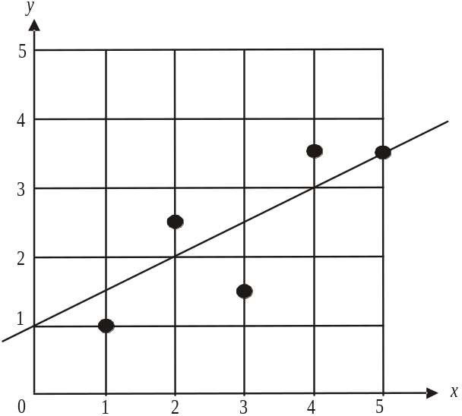

A possible residual plot could be
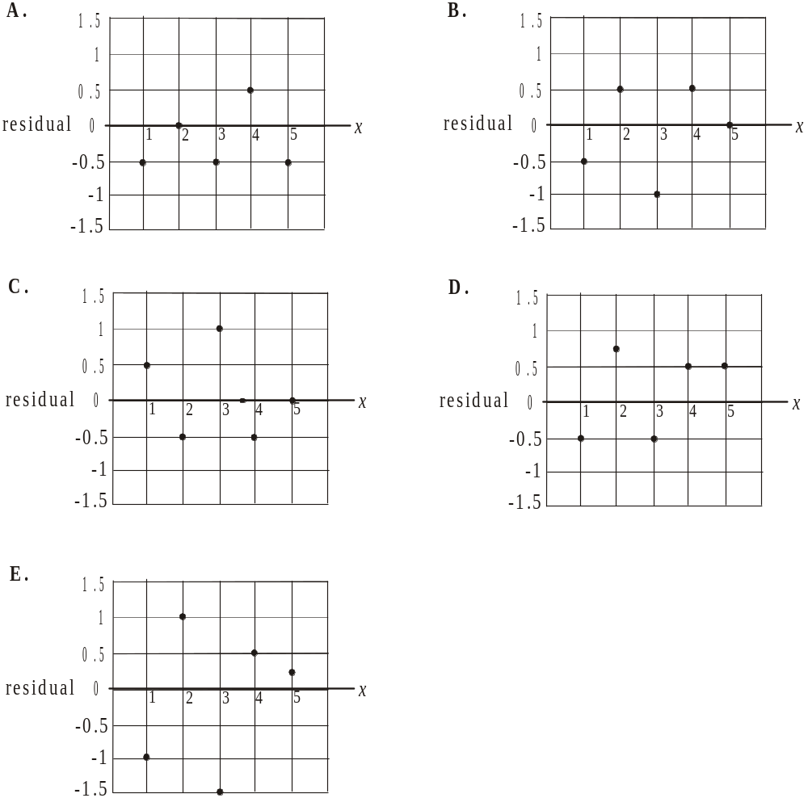

Question 10

A table of bivariate data with variables x and y together with a scatterplot showing them is given below.

x | 10 | 20 | 30 | 40 | 50 | 60 | 70 | 80 | 90
y | 85 | 63 | 48 | 32 | 22 | 19 | 15 | 12 | 6

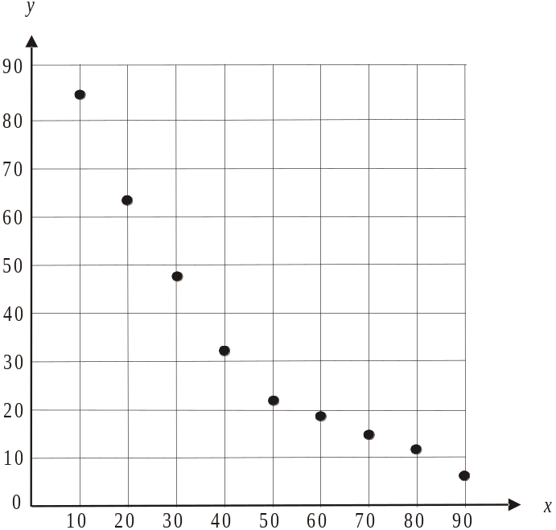

In order to linearise the data a transformation was used and a least squares regression line for this transformed data was fitted.

The equation of this least squares regression line is

- 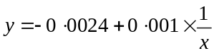
- 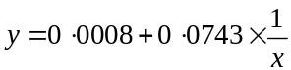
- 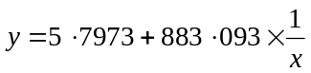
- 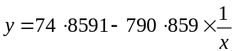
- 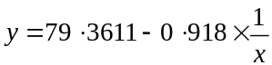

The information below relates to Questions 11, 12 and 13.

The time series plot below shows the number of visitors each season at a National Park during the first three years that it was opened up to the public.
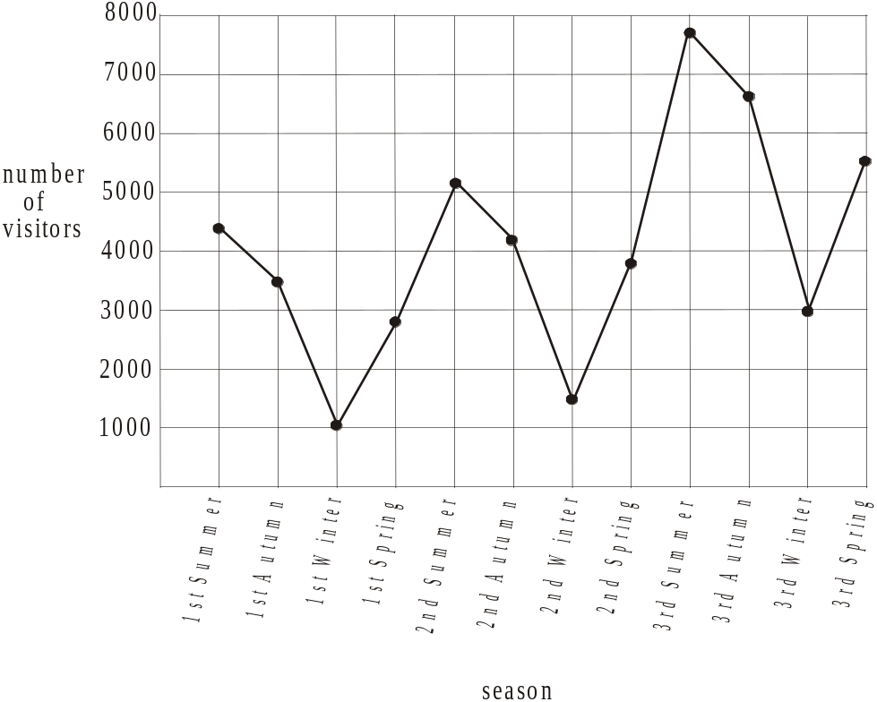

The table below shows the number of visitors each season to the National Park during its first year of opening.

Season | Year 1
Season | Summer | Autumn | Winter | Spring
Number of visitors | 4 382 | 3 524 | 1 028 | 2 946

Question 11

According to the data for Year 1, the seasonal index for the autumn quarter would be closest to

- 0.30
- 0.35
- 0.84
- 1.19
- 1.48

Question 12

In an attempt to smooth this data the method of 2-mean smoothing with centring was used. The smoothed value for Autumn of Year 1 is

- 2 276
- 2 970.5
- 2 978
- 3 114.5
- 3 953

Question 13

A trend line is fitted to the data and its equation is given by

where the summer of the first year of opening corresponds to season number 1, the autumn of the first year of opening corresponds to season number 2 and so on.

According to this trend line, the number of visitors forecast to visit the National Park during the winter of the fifth year of opening would be

- 7 755
- 9 006
- 9 423
- 9 840
- 11 091

SECTION B

Module 1: Number patterns

If you choose this module all questions must be answered.

Question 1

Which one of the following sequences shows the first five terms of a geometric sequence?

- 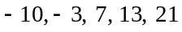
- 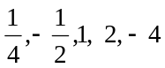
- 1, 3, 5, 7, 9
- 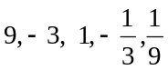
- 24, 6, 1.5, 0.2, 0.08

Question 2

The third term of an arithmetic series is 6 and the fifth term is 14.
The first term is

- – 4
- – 2
- 0
- 2
- 4

Question 3

The owner of a new small business plans to distribute 250 pamphlets to households during the first week of operation. He plans to distribute 310 pamphlets during the second week and 370 during the third.

If he continues in this pattern, the number of pamphlets he will need in the first 26 weeks of operation is

- 1 750
- 24 250
- 26 000
- 28 260
- 30 000

Question 4

Subscribers to a magazine have been decreasing by 36% each year since 2004.
There were 3 200 subscribers in 2004.
The number of subscribers in 2007 will be closest to

- 415
- 839
- 1 152
- 1 311
- 2 048

Question 5

At a trout farm, the number of trout is increasing naturally by 38% per year. The farm started with 1650 trout and at the end of each year 550 trout are sold.
A difference equation that represents the number of trout 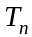 at the start of the 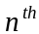 year of operation of the trout farm is given by

Question 6

A difference equation is defined by the rule,

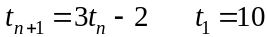.

The sequence that this difference equation generates is

- arithmetic with
- geometric with
- arithmetic with
- geometric with
- neither arithmetic nor geometric.

Question 7

The sequence given by
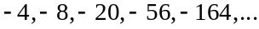

can be generated by the difference equation

- 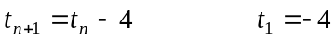
- 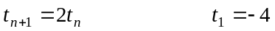
- 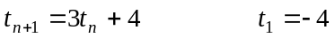
Question 8

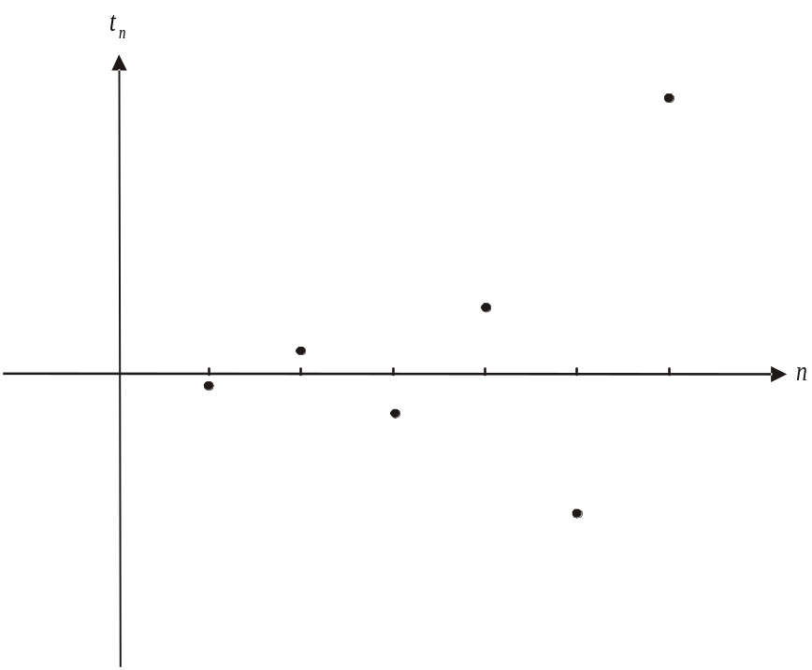

The graph above shows the first six terms of a geometric sequence of the form 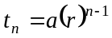.
It is true to say that

Question 9

A vineyard produces 90 tonnes of grapes in its first year. If drought and disease were to slash each harvest after that by 15% of the previous year’s production, then the total production, in tonnes, of the vineyard over the years would be

- 360
- 567
- 600
- 1 280
- 1 800

Module 2: Geometry and trigonometry

If you choose this module all questions must be answered.

Question 1

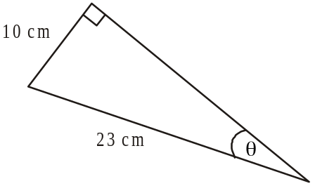

In the right-angled triangle above, the size of the angle is closest to

- 23°
- 26°
- 41°
- 45°
- 64°

Question 2

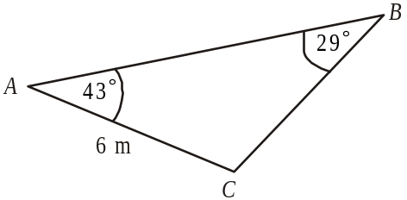

In the triangle above, the length of BC, in metres, is closest to

2.1
- 4.3
- 5.9
- 6.7
- 8.4

Question 3
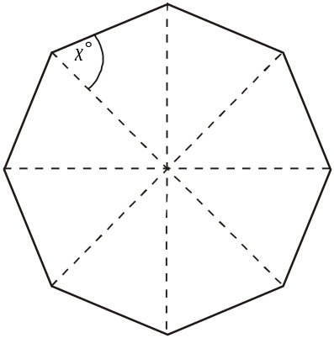

The diagram above shows a regular octagon.
The size of angle x is

- 60°
- 62.5°
- 65°
- 67.5°
- 75°

Question 4

From a 65m high cliff, a man at M, spots a whale at W in the sea below, 850m from the base of the cliff.
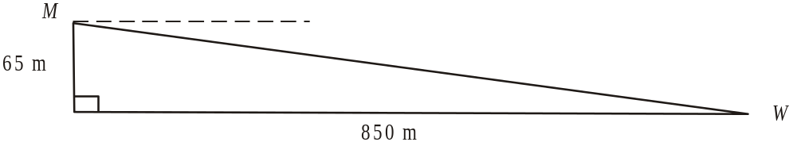

The angle of depression of the man’s line of sight to the whale is closest to

- 4.37°
- 4.39°
- 4.53°
- 4.72°
- 4.81°

Question 5

Olive oil comes in large tins of height 40cm and small tins of similar shape. The volume of a large tin is 24 000cm and the volume of a small tin is 3 000cm.
The height of a small tin is

- 5cm
- 8cm
- 9cm
- 16cm
- 20cm
Question 6

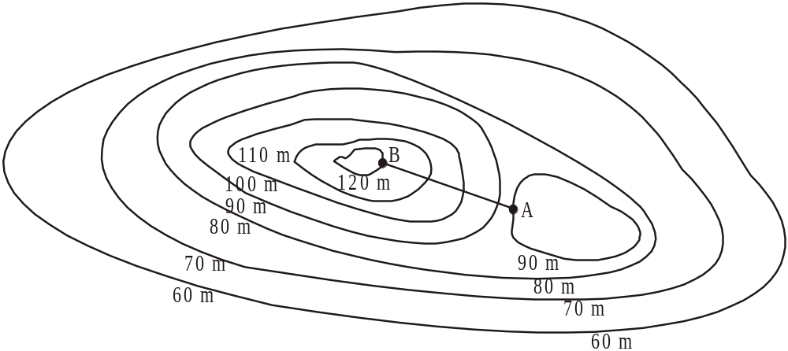

Points A and B are shown on the contour map above. They are a horizontal distance of 185m apart.
The length of the straight line AB, in metres, is closest to

183
- 186
- 187
- 189
- 211

Question 7

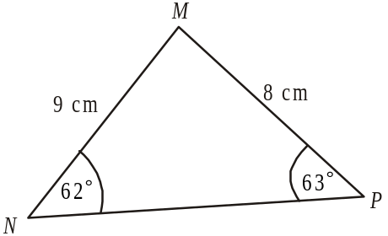

The area, in cm, of is closest to

- 29.5
- 31.8
- 32.1
- 32.6
- 33.5

Question 8

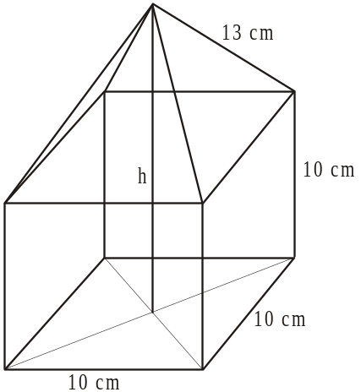

A square pyramid rests on a cube. The sidelength of the base of the pyramid is 10cm as is the sidelength of the cube. The slant edges of the pyramid are 13cm in length.
The height h, in cm, of the shape is closest to

- 10.9
- 14.8
- 16.7
- 20.9
- 24.8

Question 9

A bush allotment is in the shape of a triangle with corner points at A, B and C.
A is due north of B and the bearing of C from A is 150°.
The border AC is 2km long and the border AB is 3km long.
The length of the border BC, in km, is given by

- 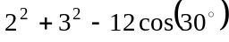
- 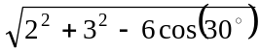
- 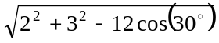
- 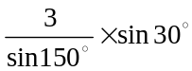
- 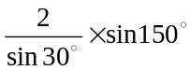

Module 3: Graphs and relations

If you choose this module all questions must be answered.

Question 1
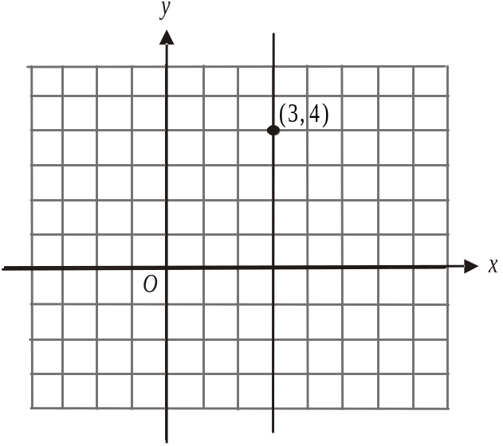

On the graph above, the straight line shown passes through the point 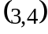.
The equation of the line is

- 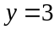
- 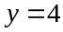
- 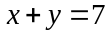

Question 2

The lines with equations 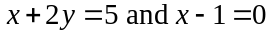 both pass through the point

- 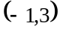
- 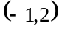
- 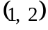
- 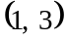
- 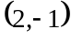

Question 3

Which one of the following shows the graph of 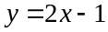?

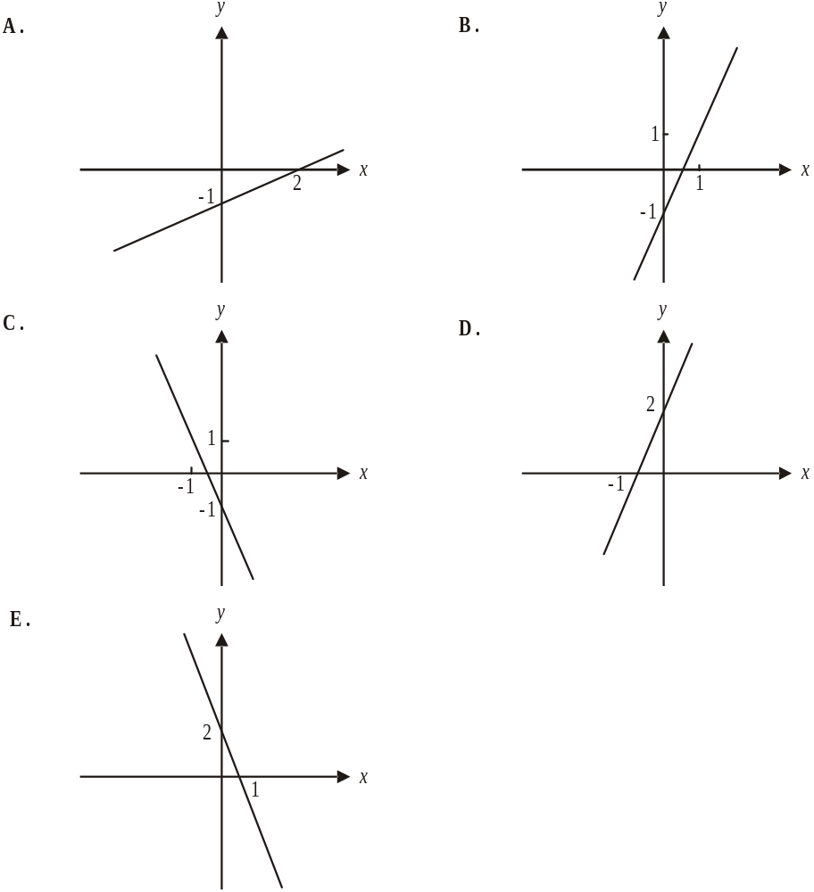

Question 4

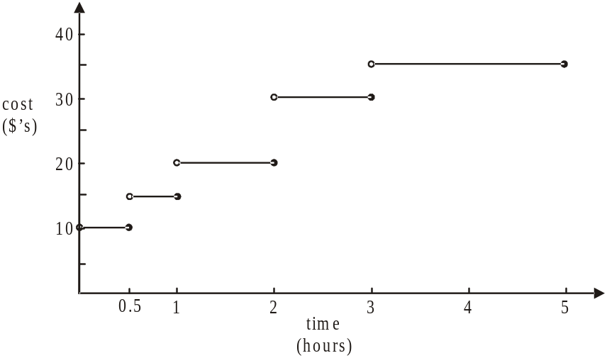

The cost of parking in a city carpark is shown on the graph above. Jacinta parked in this carpark on three consecutive days and paid a total amount of $60.
Which one of the following statements could be true?

- Jacinta parked for 45 minutes on each of the days.
- Jacinta parked for 45 minutes, 1 ½ hours and 3 hours on consecutive days.
- Jacinta parked for, 25 minutes, 45 minutes and 4 ½ hours on consecutive days.
- Jacinta parked for 45 minutes on each of two days and for 4 hours on the third day.
- Jacinta parked for 1 ½ hours on two days and 2 ½ hours on the third.
Question 5

In a linear programming problem involving staff working at a function for a catering firm, the variable y represents the number of waiting staff required and the variable x represents the number of kitchen staff required.
The diagram below shows the feasible region with the boundaries included for the problem.
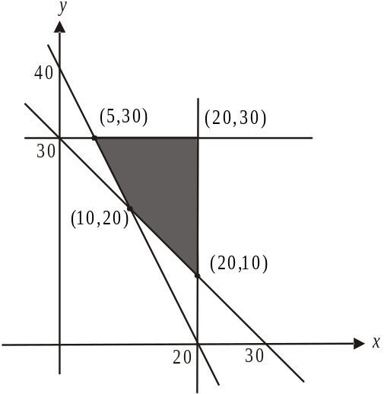

From the feasible region we know that in total the maximum number of kitchen and waiting staff possible at the function is
- 25
- 30
- 35
- 50
- 60

Question 6

The cost C, in dollars, of a house call by a washing machine repairman is given by 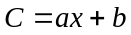 where a is the hourly rate, b is the fixed cost for a house call and x is the number of hours charged. The repairman visited 1 house for 2 hours and charged $195. He was at another house for 3 hours and charged $255.
The fixed cost for the house call is

- $50
- $55
- $60
- $65
- $75

Question 7

Jane produces birthday cards. At a market last week she broke even after having sold 48 cards at $4 each. Her fixed costs for producing the cards were $72.
How much does it cost for Jane to produce one card?

- $1.20
- $1.50
- $1.80
- $2.50
- $3
Question 8
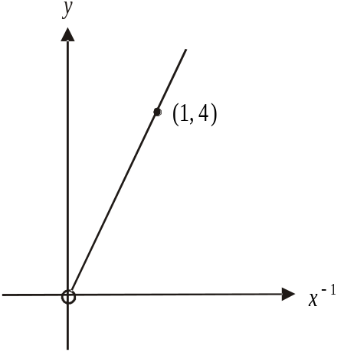

A graph showing the relationship of y against 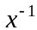 is shown above.
The same relationship between y and x is shown on which one of the following graphs?
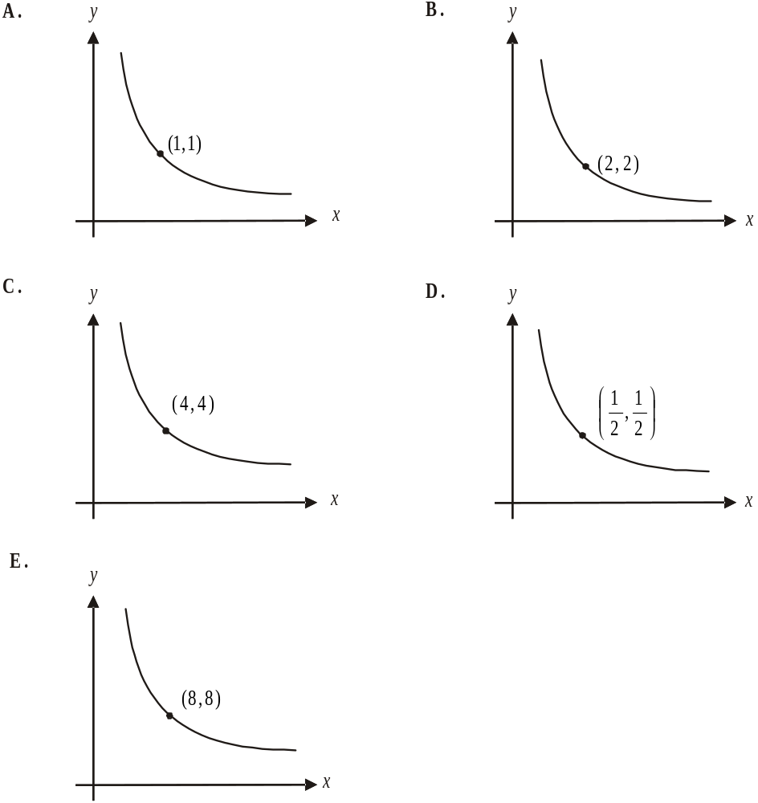

Question 9

The feasible region in a linear programming problem is defined by the inequalities below.

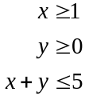

Which one of the following points does not lie in the feasible region?

- 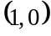
- 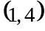
- 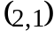
- 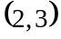
- 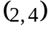

Module 4: Business-related mathematics

If you choose this module then all questions should be answered.

Question 1

A sum of $739.60 is earned in simple interest on an investment of $8600 over two years.
The annual interest rate would have been

- 4.3%
- 5.8%
- 8.6%
- 11.6%
- 17.2%

Question 2

Oliver’s bank statement for June is shown below with three missing entries.

Date | Transaction details | Withdrawals | Deposits | Balance
01-Jun | Opening balance |  |  | 294.16
07-Jun | Deposit – branch |  | 42.00
15-Jun | Direct debit
30-Jun | Interest |  | 1.43 | 272.59

The amount that Oliver had directly debited from his account on 15 June was

- $19
- $20.14
- $42
- $62.14
- $65

Question 3

James has $1800 invested in an account that earns compound interest of 6.2% per annum compounding quarterly.
The interest he will have earned on this investment after 3 years will be

- $85.00
- $364.87
- $122.46
- $1904.81
- $2164.87

Question 4

A machine used in the production of aluminium cans was purchased for $32 000.
Its value depreciates by 1 cent for every can it helps produce.
The machine is replaced when its book value is $12000.
By the time it is replaced, the number of cans the machine will have helped produce is

- 20 000
- 32 000
- 1 200 000
- 2 000 000
- 3 200 000

Question 5

Monica retires and invests $320 000 in a perpetuity that gives an annual interest rate of 5.8%.
Monica’s monthly pension from the perpetuity will be closest to

- $223
- $662
- $1 547
- $4 598
- $18 560

Question 6

Joe borrows $75 000 from a bank and is charged interest of 10.5% per annum calculated each 6 months. He repays $5 200 at the end of each 6 month period over the course of the loan.
The number of years that it takes for Joe to fully repay the loan is closest to

- 5.5
- 7.7
- 11.0
- 13.8
- 27.7

Question 7

Greta and Sean have taken out a reducing balance loan of $340 000 at a fixed interest rate of 9% per annum calculated monthly. They make monthly repayments of $P so that in 5 years time they will owe just $80 000 on their loan.
The value of P is

- 7 057.84
- 8 118.51
- 10 382.01
- 11 024.84
- 36 129.62

Question 8

Tim bought a car worth $8 500 from a car dealer. He entered an agreement whereby he paid a deposit of $800 and monthly repayments of $350 for two years.
The effective interest rate Tim will be paying on this deal is closest to

- 4.12%
- 4.36%
- 4.55%
- 7.91%
- 8.73%

Question 9

Brodie invests $80 000 in an annuity which earns 5.2% interest per annum for the first two years and then changes to 5% for the remainder of the term of the annuity.
During the whole term of the annuity, Brodie receives monthly payments of $750.
The entire term of the annuity, in months, is closest to

- 79
- 102
- 118
- 142
- 159
Module 5: Networks and decision mathematics

If you choose this module all questions must be answered.

Question 1

Which one of the following graphs is a connected graph?

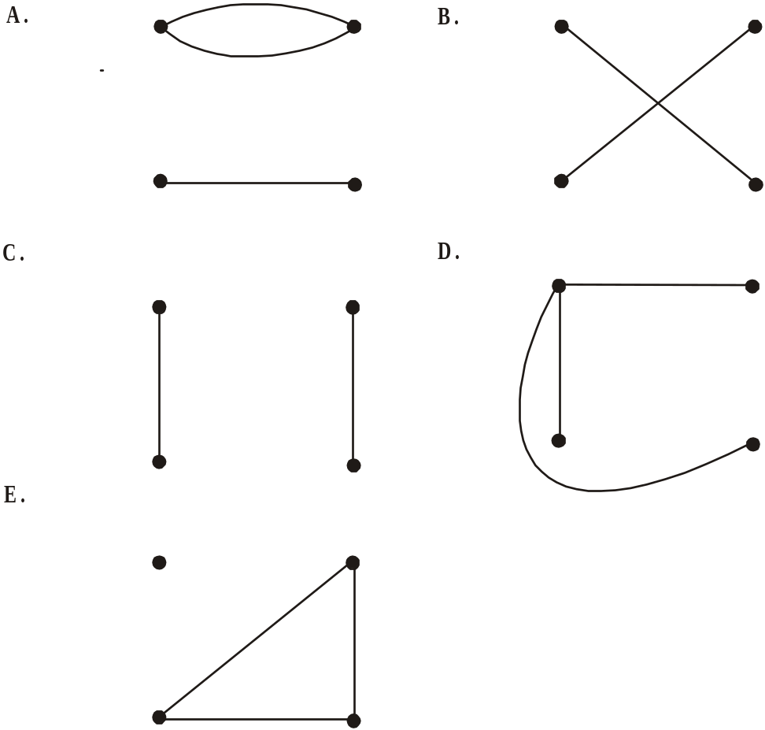

Question 2

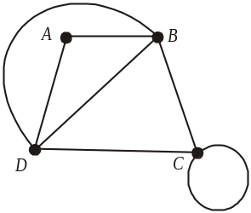
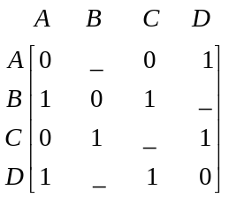

A graph together with its adjacency matrix are shown above. Four of the entries in the adjacency matrix are missing.
The sum of the 4 missing entries is

- 2
- 3
- 4
- 5
- 6

Question 3

A connected, planar graph has 5 vertices and 6 edges.
A further 4 edges were added to the graph.
The number of faces increased by

- 3
- 4
- 5
- 7
- 8

Question 4

The bipartite graph below shows the jobs that four graduates are qualified to do.

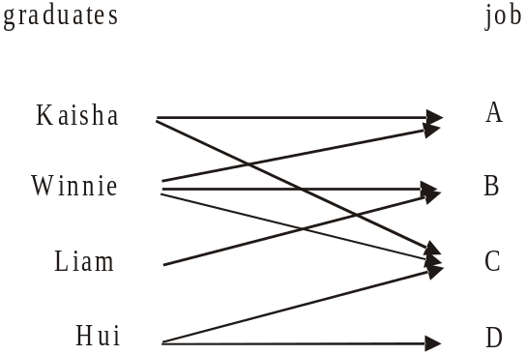

A possible job allocation would be

graduate | job
Kaisha | C
Winnie | B
Liam | A
Hui | D

C.
graduate | job
Kaisha | A
Winnie | D
Liam | B
Hui | C
E.
graduate | job
Kaisha | C
Winnie | D
Liam | B
Hui | A

B.
graduate | job
Kaisha | C
Winnie | A
Liam | B
Hui | D

D.
graduate | job
Kaisha | A
Winnie | C
Liam | D
Hui | B

Question 5

Which one of the following graphs contain an Euler path?

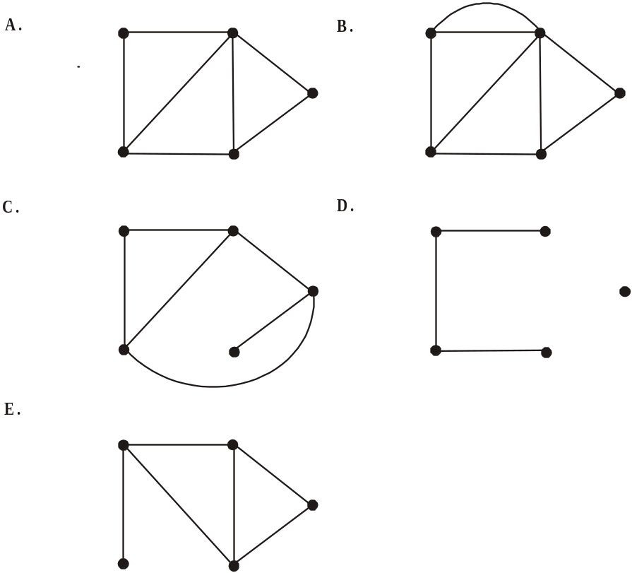

Question 6

A round robin netball competition between four teams is played. The directed graph below gives the results of the matches where an arrow from A to B indicates that A defeated B.
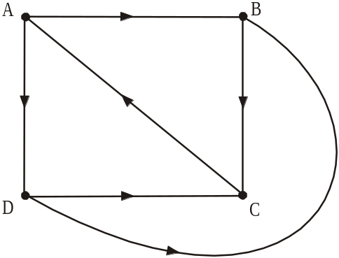

The matrix that shows the one and two step dominances between the four teams is

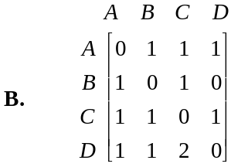
- 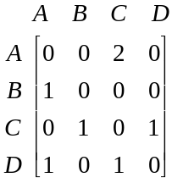

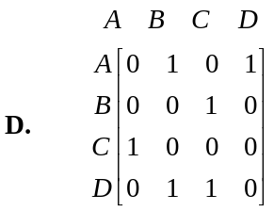
C. 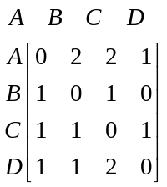

- 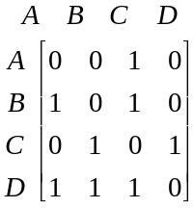

The information below relates to Questions 7 and 8.

The network below shows the activities; and the time in days needed to complete them, required to complete a project.

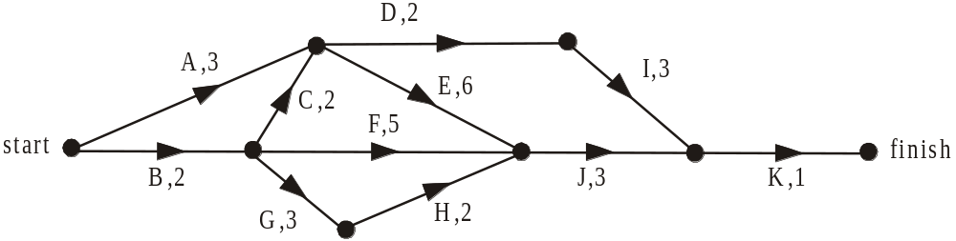

Question 7

The immediate predecessor(s) of activity E is/are

- A
- A,C
- A,D
- A,B,C
- A,C,D

Question 8

The project is to be crashed by reducing the completion time of just one activity.
The maximum possible reduction in the completion time of the project is

1 day

2 days
- 3 days
- 4 days
- 5 days

Question 9

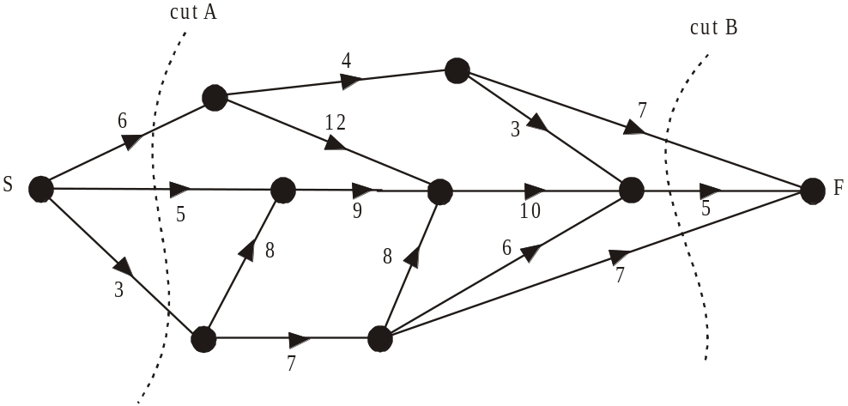

The graph above shows the capacities on the edges through a network.
Using only cuts A and B shown on this network it can be concluded that the maximum flow from S to F

is 14
- is 19
- cannot be less than 19
- cannot be greater than 19
- cannot be greater than 14

Module 6: Matrices

If you choose this module all questions must be answered.

Question 1

The matrix expression
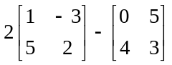 is equal to

- 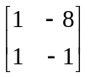
- 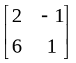
- 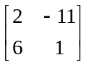
- 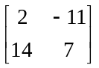
- 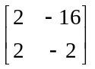

Question 2

If 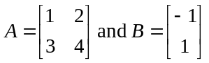then 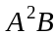 is equal to

- 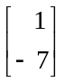
- 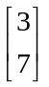
- 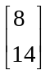
- 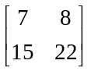
- 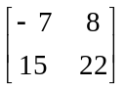

Question 3

The clothing brand Sportygirl sell black pleated winter skirts in sizes 8 -14. The number of these skirts available at four of the brands retail outlets is shown in the table below.

 | Size 8 | Size 10 | Size 12 | Size 14
Outlet A | 6 | 3 | 4 | 6
Outlet B | 2 | 2 | 5 | 2
Outlet C | 5 | 4 | 3 | 4
Outlet D | 4 | 7 | 5 | 3

A matrix that shows the number of different sized skirts at outlet B is

- 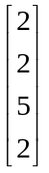

- 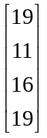

- 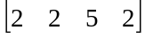

- 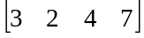

- 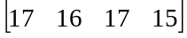

Question 4

The hourly pay at different rates for junior employees in a business is shown in Table 1 below.

Hourly rate | 15 year old | 16 year old | 17 year old | 18 year old
normal rate | $12.60 | $14.50 | $16.80 | $19.90
penalty rate | $15.60 | $17.50 | $19.80 | $22.90
overtime rate | $18.10 | $20.00 | $23.50 | $25.70
weekend rate | $17.80 | $18.60 | $20.40 | $23.40
Table 1

The number of hours worked in a week in each of the different pay rate categories for each of
the different aged junior employees is shown in Table 2 below.

Hourly rate | 15 year old | 16 year old | 17 year old | 18 year old
normal rate | 42 | 35 | 41 | 16
penalty rate | 17 | 42 | 18 | 29
overtime rate | 16 | 31 | 23 | 31
weekend rate | 23 | 18 | 31 | 14
Table 2

The total amount to be paid in the week to the 17 year old junior employees across all the different pay rates is given by

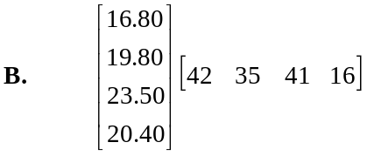
- 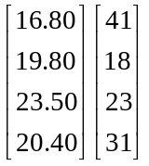

C. 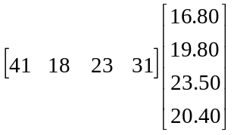
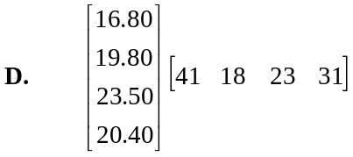

E.

Question 5

The set of simultaneous equations

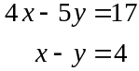

can be solved by evaluating the matrix product

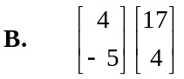
- 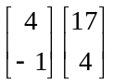
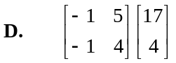
C. 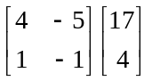
E. 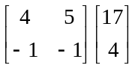

Question 6

A, B and C are matrices and C has three rows. If the matrix expression 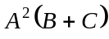 exists, then the order of matrix A is

Question 7

Workers in a large office building patronise three cafes, A, B and C nearby. The number of these patrons at each café each week was given initially by

Café | Number of patrons in a week
A | 682
B | 798
C | 1043

The patrons vary which café they go to according to the transition matrix T where

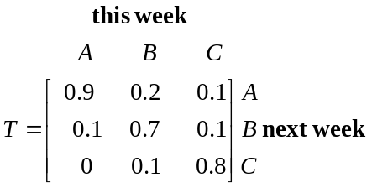

Over the long term, if this pattern continues, the weekly number of patrons at Café B would be closest to

- 631
- 634
- 644
- 731
- 798

Question 8

Jillian takes her dog Tootsie to three different vets Dr Wags (W), Dr Claw (C) and Dr Barker (B).
If Jillian has taken Tootsie to one vet, she won’t return there next time and is equally as likely to visit either of the other two vets.
The transition matrix showing the way Jillian changes vets is given by

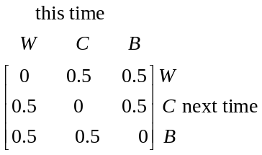
- 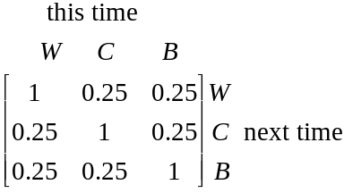 B.

D. 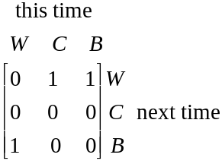
C. 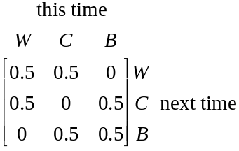

E. 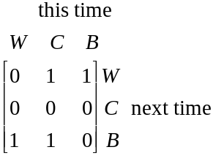

Question 9

When it’s raining this hour in any of three districts A, B or C, the likelihood that it will be raining in any of the districts in the next hour, is given by the transition matrix

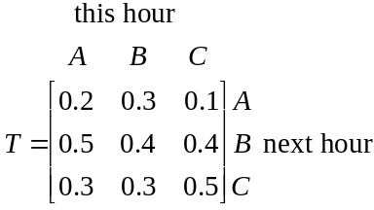

Which one of the following statements is true?

- If it’s raining in district A this hour the likelihood of it raining in district C next hour is 0.2.
- If it’s raining in district C this hour the likelihood of it raining there again next hour is 0.1.
- The likelihood of it raining in consecutive hours in district B is greater than 0.5.
- The likelihood of it raining in consecutive hours in district C is less than 0.5.
- The likelihood of it raining in consecutive hours in district A is less than 0.5.
Further Mathematics Formulas

Core: Data analysis
standardised score: 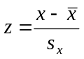
least squares line: 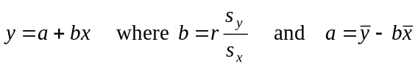
residual value: residual value = actual value – predicted value
seasonal index: seasonal index 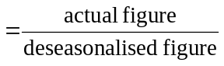

Module 1: Number patterns
arithmetic series: 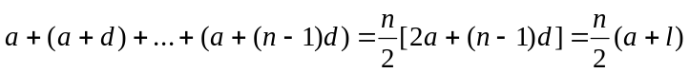
geometric series: 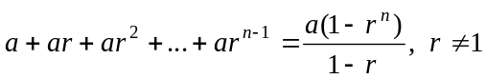
infinite geometric series: 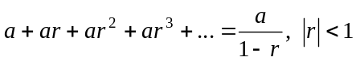

Module 2: Geometry and trigonometry

area of a triangle: 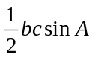
Heron's formula: 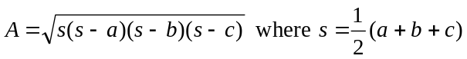
circumference of a circle: 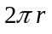
area of a circle: 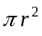
volume of a sphere: 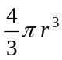
surface area of a sphere: 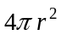
volume of a cone: 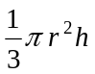
volume of a cylinder: 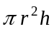
volume of a prism: 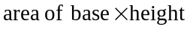
volume of a pyramid: 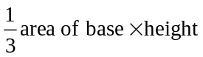

These formula sheets have been reproduced with permission of the Victorian Curriculum and Assessment Authority, Victoria, Australia.
These formula sheets have been copied in 2008 from the VCAA website www.vcaa.vic.edu.au
The VCAA publish an exam issue supplement to the VCAA bulletin.
Pythagoras’ theorem 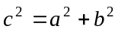
sine rule: 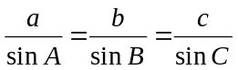
cosine rule: 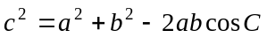

Module 3: Graphs and relations

Straight line graphs

gradient (slope): 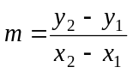
equation: 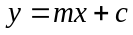

Module 4: Business-related mathematics
simple interest: 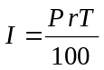
compound interest: 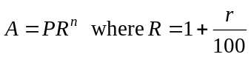
hire purchase: 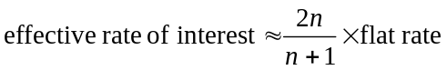

Module 5: Networks and decision mathematics

Euler’s formula: 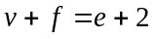

Module 6: Matrices
determinant of a 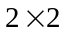 matrix 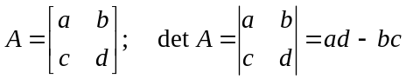
inverse of a matrix 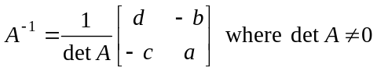

END OF FORMULA SHEET

These formula sheets have been reproduced with permission of the Victorian Curriculum and Assessment Authority, Victoria, Australia.
These formula sheets have been copied in 2008 from the VCAA website www.vcaa.vic.edu.au
The VCAA publish an exam issue supplement to the VCAA bulletin.

.


